**Air blower system Research: -**

DC motors are commonly used to make things spin or move, like robot wheels or disc drives. Before picking a motor, think about the device you're using it for. Consider things like size, connectors, and how much power it needs. Once you know what you need, check out H-Bridge circuits to control the motor properly.

An H-Bridge uses power to manage the motor's current, allowing you to control its speed using something called pulse width modulation (PWM). Knowing the details about H-Bridge circuits helps you avoid issues like the motor getting stuck, making too much noise, or having electrical problems. This article talks about what to think about when choosing an H-Bridge for your DC motor and compares some popular ones you can find.

**DC Motor Specifications for Finding Required Drive Strength**

If you're making something like a motor, gear, or fan, you need to think about what your DC motor needs. Start by figuring out how strong your motor needs to be. This helps you pick the right motor features, like how fast it needs to turn to make your device work. DC motors can spin in two ways, and you can control their rotation using something called an H-Bridge circuit.

DC brushless motors, powered by an H-Bridge, are great for things like wheels or fans. They don't need super precise rotation, but they should be able to go forward and backward. These motors typically rotate at speeds between 3000 and 8000 revolutions per minute (rpms).

To know how fast your motor needs to spin, look at its stall current and stall torque. Here's what those mean:

Rotational Speed: This is how fast something turns around an axis, measured in revolutions per minute (rpm).

**Stall Torque:** This is the maximum force needed to stop the motor from turning.

**Stall Current:** This is the maximum current needed to stop the motor from turning.

It's important not to go over the motor's limits because it could get too hot and be damaged. The stall current tells you the amount of current that makes the motor stop working, which is related to torque. So, when designing, stay just under the stall current to be safe.

To find the right motor for your project, you can search for "dc motors" on our main page. On the results page, choose "AC, DC and Servo Motors," then refine the search by clicking on "electromechanical." There, you'll find a variety of motors to pick from for your project.

**Using an H-Bridge to Drive a DC Motor**

An H-Bridge is a common setup for making things like motors, gears, or fans move. It's a circuit that lets you control the movement of a device in two directions. You can either build the H-Bridge yourself using transistors and other components or buy ready-made ICs with H-Bridge setups. For small DC motors, you usually need around half an ampere or more of current, and they work with voltages between 1.5V and 24V.

The H-Bridge works by arranging four transistors in a shape that looks like the letter "H," with the motor placed in the middle of this configuration. This setup allows you to control the motor's direction and make it move forward or backward.

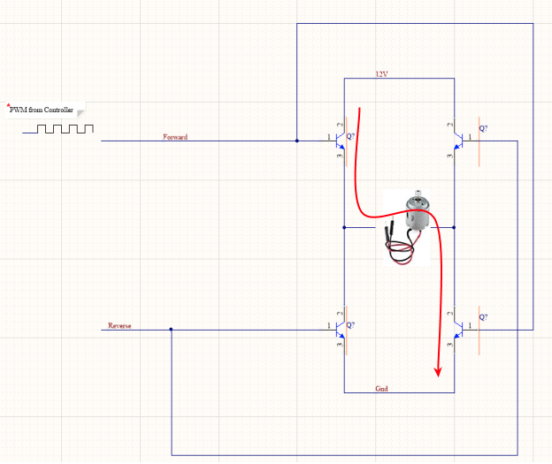

**H-Bridge topology Usage: -**

To make a motor go forward, you activate specific transistors in the H-Bridge. To make it go backward, you activate a different set of transistors. To control the speed, you use something called a pulse-width modulator. By changing the width of the pulses in a set cycle, you can control how fast the motor moves. This changing width is called the duty cycle, and it determines the amount of current, or strength, going through the motor. So, by adjusting the duty cycle, you can control the motor's speed using the H-Bridge.

However, there's a potential issue called shoot-through current that you need to be aware of in H-Bridge setups. This happens when transistors on the same side of the bridge turn on at the same time. Shoot-through currents can cause a direct short and seriously damage your transistors. To avoid this, some ICs with H-Bridge setups include a shoot-through protection feature. There are various options from different IC families available.

When it comes to selecting transistors for your H-Bridge, especially for small hobby DC motors, a general-purpose NPN transistor like 2N2222 works well. It can provide enough current to drive a small brushless DC motor. If you search on our website for the 2N2222, you'll find plenty of choices, each with pricing and packaging details. Use the search filters to narrow down your options based on what you need.

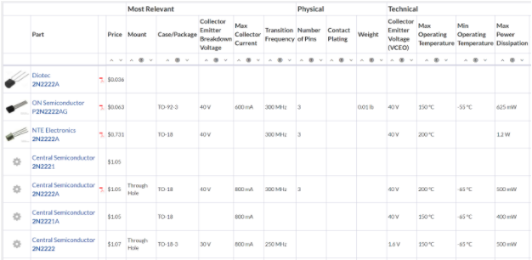

If you're looking for the least expensive 2N2222 transistors, you can filter your search based on price on our website. This way, you can find the most affordable options for your needs.

Another option is to use an H-Bridge drive IC (Integrated Circuit). This is handy if you have multiple devices to control. Using an IC offers integrated features like ESD protection, noise immunity, and protection from shoot-through currents. Here are some commonly used ICs:

**L293 series:** These devices are high-current half-H drivers. L293 can handle bidirectional drive currents up to 1A, while L293D can handle up to 600mA. They work with voltages from 4.5V to 36V and are suitable for driving things like motors and relays.

**L298P013TR:** This is a 4A integrated circuit with dual full-bridge drivers. It's designed for high voltage and high current applications, suitable for driving relays, solenoids, and motors. It can operate at lower logic voltages.

**LMD18200T/NOPB:** This 3A H-Bridge is designed for motion control. It's versatile for driving DC and stepper motors, accommodating peak output currents up to 6A. It uses a combination of bipolar and CMOS technology.

These ICs come in various package types. For easy prototyping, you can use DIP packages for solderless breadboarding. If you're working on boards for prototyping or production where space is limited, you can go for surface mount packaging styles. Use the search features on our website to find the right package type for your needs.

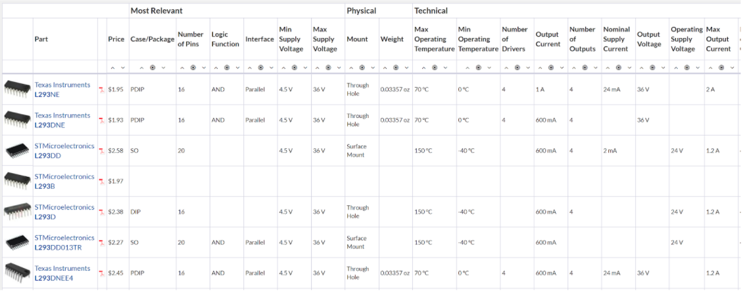

When searching for half and full bridge ICs in the L293 family on our website, it's convenient to have all the options in one place. Before you make any decisions, you need to choose between individual transistors or a drive IC. Here are the benefits of each:

**Individual Transistors:** These are great for testing and experimenting. You can arrange them on a solderless breadboard, allowing you to evaluate circuit performance using tools like an oscilloscope to observe how each part behaves.

**Drive IC:** If you're planning for production and need to consider factors like cost, PCB space, and advanced features, using an IC is a better choice. IC vendors include extra protections and design features, which can save you time and money during development.

Once you know the drive current and power requirements for your design, you can use Octopart's search engine to find the right components. Make sure you are aware of the power needs of the part you're driving, whether it's a motor, fan, or any other moving component. Understand both the power available to you and the power requirements in terms of current for providing rotational torque. This knowledge will help you make informed decisions during your search.

Top of Form

**H- bridge types difference: -**

**Transistor based** motor driver produced more heat than **MOSFET based** driver

Efficiency 40-70% More efficient 91-95%

Voltage drops 1.4DC voltage drop 0.05-0.13V

Useful for small projects useful for large project

**Project Steps: -**

Air Blower Project Important points:

1- M1 Motor is a mover motor (will move back and forth i.e. move in a backward and forward direction, trolley movement).

2- Limit switch 1 (LS A) -> For stopping the trolley when reached to its park position).

3- Signal from the MCU to start the mover motor M1. Also, RPM of the motor M1 will be controlled from the MCU (How fast & slow M1 will rotate).

4- M2 will work as an air blower in the system. (Will do two things: Blow air in the system & exhaust air from the system, in terms of clock & anti-rotation).

5- Also, for the M2 motor the rate flow will be controlled from the MCU (normally the RPM).

6- When the trolley is moving towards LS B, the M1 motor will be stopped, But the M2 motor will start rotating in the opposite direction very fast, & blow the air into the other systems or exhaust the air. (future work).

7- Once step 6 is completed, after 3 or 4 secs the M1 and M2 motor will start rotating in the direction of LS A (Idle state (parking Position)).

8- The external switch will initiate the whole process. (i.e. step 1).

**ye hain simple c KahaNiii**

**Dear Hiring Manager,**

I am writing to express my interest in the Embedded Systems Engineer position at your company, as advertised. With a solid background in hardware, firmware, and a proven ability to convert conceptual ideas into practical solutions in the realm of Embedded Systems/IOT, I believe my skills align well with the requirements of the role.

**Education:** -

I graduated from the University of Engineering and Technology Peshawar with a Bachelor's degree in Computer System Engineering. My coursework included Embedded Systems, MCU Programming, and Digital System Design, contributing to a solid foundation in these areas.

**Experience: -**

In my previous role as an Embedded Systems Engineer at Chip Soul, I gained hands-on experience with GPIO, ADC, DAC, PWM, TIMER, RTC, and various sensors. I designed firmware for different microcontrollers, including ESP32, STM32, STM8S00F, and Arduino. My expertise extends to Real-Time Operating Systems (RTOS) for efficient memory and CPU utilization. I have successfully collaborated with team members to integrate hardware and software components, ensuring seamless functionality.

**Projects: -**

I have actively contributed to diverse projects, including the design of an Air Blower System with autonomous trolley movement and a graphical dashboard project for electrical vehicles. My work on a Dashboard for Electrical Vehicles involved creating an embedded product to display battery information, and I implemented an IOT-Based Smart Irrigation System for my final year project.

**Skills: -**

My skills encompass a range of programming languages, including C, C++, Python, Verilog, and Assembly. I have extensive experience with microcontrollers such as STM32, ESP32, Arduino, and more. Proficient in communication protocols like UART, I2C, SPI, and development environments like Visual Studio, STM32CubeIDE, and Keil, I bring a comprehensive skill set to your team.

Conclusion: My commitment to innovation, strong analytical skills, and proficiency in various technologies make me confident in my ability to contribute effectively to your team. I am excited about the opportunity to bring my technical expertise to [Company Name] and contribute to its ongoing success.

Thank you for considering my application. I look forward to the possibility of discussing how my skills and experiences align with your organization's needs.

**Sincerely, Muhammad Ali**